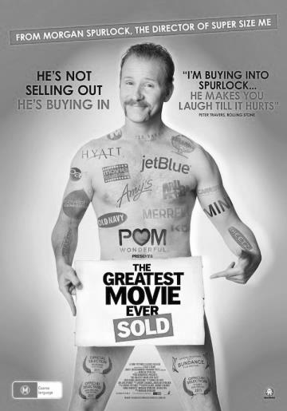
Morgan Spurlock’s documentary, POM Wonderful Presents: The Greatest Movie Ever Sold, examines product placement, marketing and advertising in movies and TV shows, by having the film itself entirely paid for by sponsors.
In the documentary, Generation Like, Douglas Rushkoff features Tyler Oakley, who has morphed his love of sharing his favourite products into a career as a YouTuber and social media expert. He claims this ‘brand integration’ is mutually beneficial.

What are you passionate about? What would you do—and how far would you go—to make a career doing the things you love?

Cenovus Energy, an oil company based out of Calgary (www.cenovus.com), has announced that they want to help fund the development of talent and innovation in the next generation. They are offering $1,000,000.00 to anyone under 20 years of age with the best proposal of how he/she will use that million to develop and showcase his/her talent while also promoting Cenovus.

The proposal should include the following, but the organization of it is up to you:

- A description of your talent. Make Cenovus believe that this is a talent worth investing in by using persuasive and compelling language.
- How you will use the money to fund the development of your talent (include a cost breakdown with explanation for things like training, equipment, transportation, accommodation, personal services, promotion/marketing). Convince Cenovus that their money will be well spent on meaningful things. Consider how you might use text and image (e.g., diagrams, charts, images of your fantastic talent and what you’ll require).
- How you will promote Cenovus in tandem with developing and showcasing your talent. Consider the main forms of marketing and describe ideas for advertising and promotion, e.g., draft print ad, storyboard for a commercial, sample Tweets. Use everything you’ve learned about advertising and media to ensure that you can effectively reach your target audience as well as Cenovus’.
- Terms and conditions. Discuss what you’re willing or not willing to do, should Cenovus think to require it. Research the company’s values and practices, and explain whether and to what extent they reflect your own values and practices. Explain how (or if) you feel you will live up to your values even while promoting Cenovus.
- Appeal. Admit something you think you need to work on for future proposals or written communication. State what you think is particularly strong or effective about your proposal and, ultimately, why you are the best investment Cenovus can make.

